**ACTIVITY 3: CREATE RECORDS TO THE MATCHER TABLE**

Enter the values for the required fields and create all the possible combination of the records.

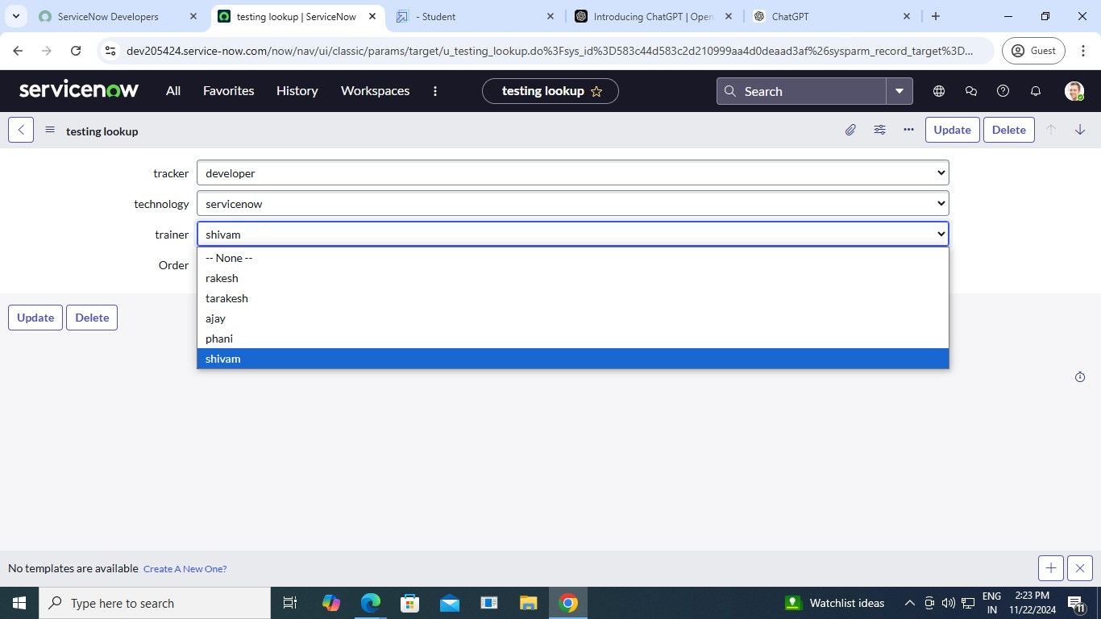

Record 1

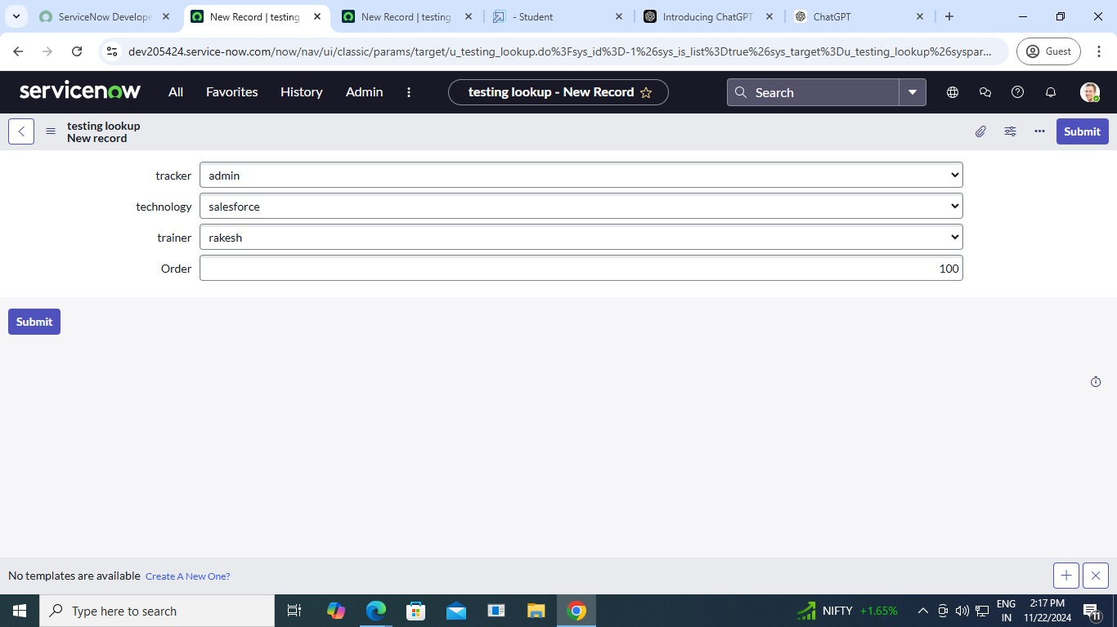

Record 2

